Parent/Student Guide

How to access our school system from home.

- Your internet browser needs to be Google Chrome.

- Search for - Gat.Airhead.io
- This should bring you to this website.
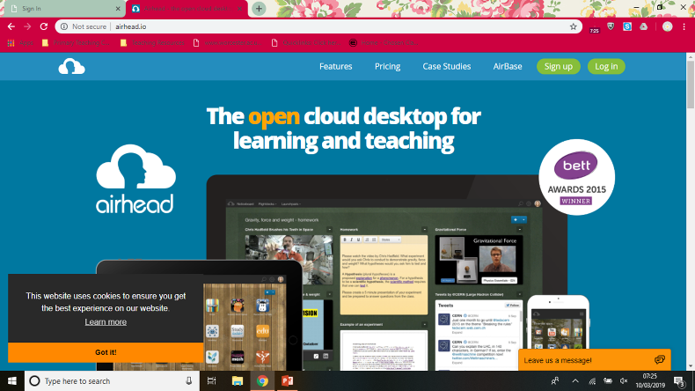
Y 4. Sign in

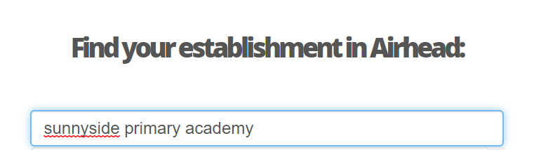
5

6.
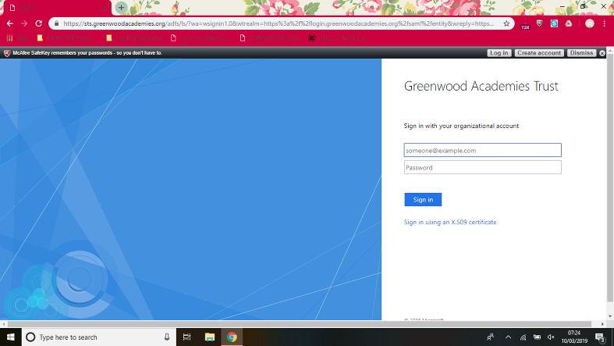

7. You need to type in your school email address and password.

Your email address is made up of the 4 letters of our surname and the 1st letter of your forename + your year group number.

For example – John Smith is in Year 3 – the log in details would be:

EYFS: 20.68
Year 1: 19.68
Year 2: 18.68
Year 3: 17.68
Year 4: 16.68
Year 5: 15.68
Year6: 14.68

smitJ17.68@sunnysideprimaryacademy.org

You should be taken to your school Launchpad – the school Launchpad has links for you to access TT Rock Stars and Purple Mash.

8. You need to open Microsoft Teams – your teacher will have invited you.

9. Search for your class

10.

Posts – This is where you can post messages to your teacher and class.

11.

Files – Your teacher may upload useful information here.

12.

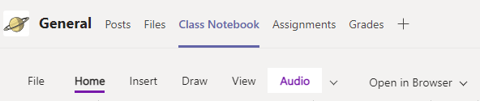

Class Notebook – This is where you will do all of your work – you will need to open the browser – it makes it easier.

On the left hand side there will a selection of tabs – see picture below.

There will be subject tabs

Click on a subject – eg Maths

This will take you to a contents page – there will be dates for each week.

Find the current week

There will be power points for you to download.

13. Dates content page

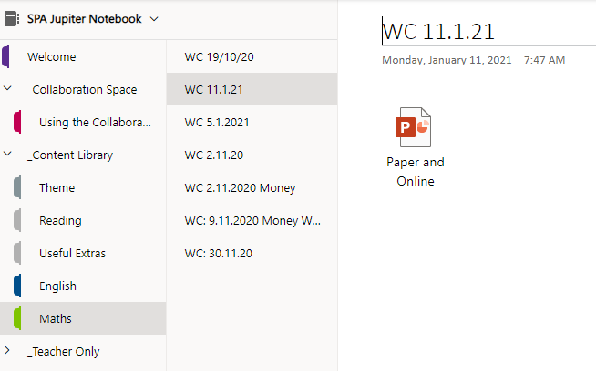

On the picture above – Maths has been selected –

This brings the weeks – and then you can see the work available.

14. – Work completed needs to be uploaded into your own page – no other class member has access to this page.

15. Links to Live Lessons and Assemblies

Each day there will be invites to live catch ups – these are in the morning and in the afternoon. You will find the invites in your Teams Calendar – see picture below.

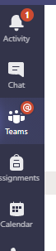 The calendar is where you will find invites to assemblies and live lessons.

16.

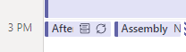

You need to click on the Afternoon catch up/Assembly or lesson.

17.

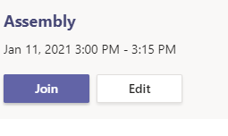
Click join – please be patient as you have to wait for the organiser to let you in.

